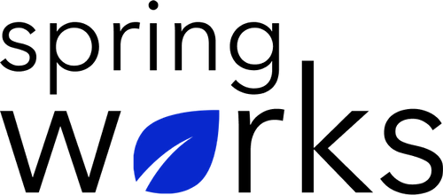
Free Template – Training Needs Assessment Survey

Find out what your participants want to know ahead of their training session

The only purpose of this survey template is to help you identify training priorities. Copy this template to your Google Drive and customize it for your organization.

Communication (to be added as review instructions):

All answers you give will be treated with the utmost sensitivity, and the information will not be used for any other purpose apart from planning and improvement. Please answer this quick survey by <HOUR OF THE DAY> on <DATE>.

Demographic Information:

The following information is requested so that meaningful analysis and comparisons of group results can be made. Please check the circle corresponding to your answer.

Q: Your Department:

- Marketing
- Operations
- Tech
- Accounting
- HR

Q: Company Service:

- Under 1 Year
- 1-2 Year
- 3-5 Year
- 6-10 Year
- 10-15 Year
Training Needs Assessment Questionnaire

To answer clearly what you think or feel about each item, please follow these steps:

- Read each item fully before you start to mark your answer.
- Pick the one answer which most nearly says what you think or how you feel.
- While completing the questions, be sure to read the special instructions which are included.

Q: We're offering a number of training sessions. Please select which you'd most like to attend.

- Public speaking
- Digital skills
- Health and Safety
- Management skills
- Productivity and time management

Q: How would you currently rate yourself on _____?

1 | 2 | 3 | 4 | 5

Q: What are you hoping to learn in the _____ session?
(Please add as much detail as possible)

Q: Have you attended professional training before?

- Communication skills
- Leadership skills
- Administration skills
- Digital skills
- Other

Q: Knowing how to work and collaborate with others to accomplish goals and objectives

- Strongly agree
- Agree
- Neutral
- Disagree
- Strongly disagree

Q: Knowing how to make more effective use of web-based calendars and To-Do lists.

- Strongly agree
- Agree
- Neutral
- Disagree
- Strongly disagree

Q: Do you feel qualified to handle your current scope of work?

- Not at all
- Slightly
- Moderately
- Very
- Extremely

Are you given enough mentoring and tutelage for your current work?

- Not at all
- Slightly
- Moderately
- Very
- Extremely

Q: Do you feel that more training is needed for employees?

- Yes
- No
- Not sure

Q: Would you attend training workshops held by the company?

- Yes
- No

Q: How long would you like training workshops to last?

- A day
- 2-3 days
- 4-5 days
- More than a week

Q: Would you like to be updated on training workshop news and events?

- Yes
- No

Q: Any other feedback or suggestions?

Thank you for sharing your opinions.

